The Extended Abstract(Prooceding) Including Min 2 and Max 3 pages
TITLE“Arial, 12 points, bold”

^{1*}Name Surname, ²Name Surname, ³Name Surname, “Arial, 9points”
¹ Affiliation University, Faculty, Department, InstituteAddress, City, Postal Code, Country“Arial, 9points”
² Affiliation University, Faculty, Department, InstituteAddress, City, Postal Code, Country
³ Affiliation University, Faculty, Department, InstituteAddress, City, Postal Code, Country

* E-mail:xxx@yyy.com“Arial, 9 points”
Abstract
“Arial, 10 points, max 250 words”.
..
…

Keywords:“Arial, 10 points, bold” Keyword, keyword, keyword, “Arial, 10 points”

I. Introduction“Arial, 10 points, bold”
“Arial, 10 points, max 250 words”
….
…..

II. Material and method “Arial, 10 points, bold”
“Arial, 10 points, max 250 words” Chemistry chemistry

III. Results and discussion“Arial, 10 points, bold”
“Arial, 10 points, min 250- max 500 words”

IV. Conclusion“Arial, 10 points, bold”
“Arial, 10 points, max 150 words”

Acknowledgements“Arial, 10 points, bold”
“Arial, 10 points, max 20 words”

References“Arial, 10 points, bold”
“Arial, 9 points, alphabetic order of names (fist author), max 5 important refs.”

APA format must be used to list the references.

If there is figure or Table, they must be given in the text

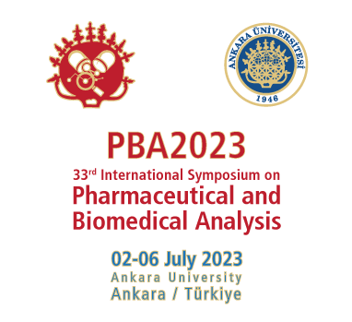

Fig. 1:“Arial, 9 points, Centered, and graph aligned on the chemistry”Experimental installation

Tab. 1:“Arial, 9 points, centered, and table aligned on the chemistry”Example chemistry chemistry chemistry chemistry chemistry chemistry chemistry chemistry chemistry

Chemistry | Chemistry | Chemistry | Chemistry | Chemistry
Chemistry | 1 | 2 | 3 | 4
Chemistry | 1 | 2 | 3 | 4
Chemistry | 1 | 2 | 3 | 4
Chemistry | 1 | 2 | 3 | 4
Chemistry | 1 | 2 | 3 | 4
Chemistry | 1 | 2 | 3 | 4

